최적제어 HW 5

2017321117 김푸름

1

Nomenclature
Notation
Angular displacement from the reference axis
Thrust direction
Gravitational force exerted on the vehicle by the moon
Gravitational constant at the surface at the moon
Mass of the spacecraft
Radius of the moon
Distance of the vehicle from the center of the moon
Instantaneous velocity vector of the spacecraft

The space vehicle is in the gravity field of the moon. Assume that the motion is planar, and that the thrust magnitude is constant. The control variable is the thrust direction , which is measured from the local horizontal. For simplicity we think of the space as a particle of mass and will neglect the change in mass due to fuel consumption. is the gravitational constant at the surface of the moon, and is the radius of the moon. is the distance of the vehicle from the center of the moon. The gravitational force exerted on the vehicle is given by
.

We define the state of the space vehicle as below. is the angular displacement from the reference axis.

And finally, let us define the vector as the instantaneous velocity of the spacecraft.

The state equations are
.

Mission a
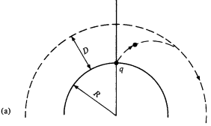
Suppose that the spacecraft is to be launched from the point on the reference axis at into a circular orbit of altitude in minimum time. is unspecified, and the spacecraft starts from rest; thus, the initial conditions are
.

The final time is free. At , must be satisfied. As the final orbit is circular, its radial velocity must equal to zero. Also, for the orbit to be a circular one, the centripetal force must equal to the gravitational force of the moon.
Thus, at , the final state is given by
.

The performance measure is given by
and the Hamiltonian is
.

The optimality condition and the costate equations are given by
.

Solving for gives

Now we need to find the boundary conditions. Since the state has four elements in it and we also need to determine , we will need nine boundary conditions to solve this problem. We actually have seven of them from the given boundary conditions and . The only unknowns are and . For these two, we have
.

Mission b
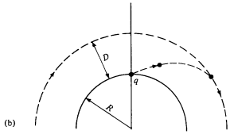
In this mission, the spacecraft is to be launched from point and is to rendezvous with another spacecraft that is in a fixed circular orbit that is above the moon with a period of two hours. At , both spacecraft are on the reference axis. The rendezvous is to be accomplished in minimum time.
---

This problem is different from Mission a only by its boundary conditions. In this case, the final state of the spacecraft is on the moving , which refers to the state of the target spacecraft. Note that .
Notice that only depends on , so we have
.
For to be zero for any arbitrary , it must be true that
.

The initial state , and form the nine required boundary conditions.

Mission c
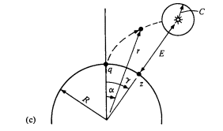
A satellite is in synchronous orbit above the point on the moon. Our goal is to get the spacecraft to any point that is away from the satellite, as soon as possible. The initial state , the state equations and the performance measure are the same as the Mission a, and therefore the optimality condition and the costate equations also remain unchanged. The only difference is that the final state is on the curve given by
,
which is a circle of radius with the center being the satellite.

Refer to the sixth case in the table on lecture note p. 65, and we have a boundary condition from the constraint.
Applied to our case, becomes
.
We need to compute first.

With through , the boundary conditions are now

In this mission, we need ten boundary conditions rather than nine because of . The initial state and the boundary costate provides eight of them, and the remaining two are given by and
.

Mission d
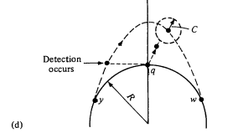
The mission here is to get the spacecraft to any point that is away from another spacecraft whose position history is given by the relation
Note that the curve is now also a function of .

Again we have four boundary conditions from
.
As we did with Mission c, we first compute first.

With through , the boundary conditions are now

In this mission, again, we need ten boundary conditions. The initial state and the boundary costate provides eight of them, and the remaining two are given by and

2
Find the optimal control law for the system
to minimize the performance measure
.
The admissible state and control values are unconstrained, the final time is specified, , and is free.

In this particular problem, is given by the differential equation
with the boundary condition . Solving the differential equation gives the solution
where can be determined from the boundary condition as below.

Then, the costate equation and the optimal control law can be expressed as
.
Then the linear state equation can be expressed as follows.

Let . For each case (of different ’s), the histories of and are plotted as below.

3
The augmented functional and its variation are given by
.

Substituting into gives
.

Necessary conditions

